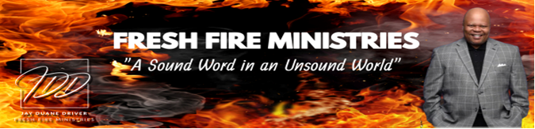

Word Wednesday Bible Study Guide

July 16, 2025

“Back to the World”

“So all the congregation lifted up their voices and cried, and the people wept that night….” Numbers 14:1-5 (NKJV)

I. Subtext
A. John 15:18-19

II. What Jesus Said
- Luke 9:57-62

III. What Paul Said
- Romans 12:1-2

IV. What Peter Said
- II Peter 2:20-22

V. What John Said
A. I John 2:15-17

Next Week: “The Theology of the Oil”

