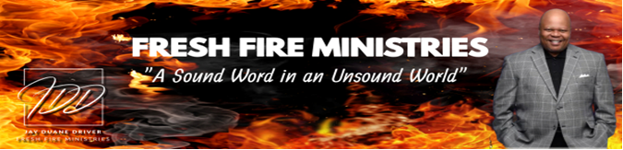

Word Wednesday Bible Study Guide

May 28, 2025

“You’re in Your Feelings”

“Who being past feeling, have given themselves over to lewdness, to work all uncleanness with greediness.” Ephesians 4:19 (NKJV)

I. Subtext
A. Hebrews 4:12

II. The Emotion of Praise
- Psalm 147:1 (KJV)
- II Samuel 6:12, 12, 20

III. The Emotion of Spiritual Gifts
- I Corinthians 14:22-25, 26,40

IV. The Emotion of Worship
- John 4:23-24

V. The Emotion of Giving
A. Matthew 6:39-42
B. I Timothy 2:5

Next Week: NEGLIGENCE: “What Happened to Prayer & Fasting?” Part 1

