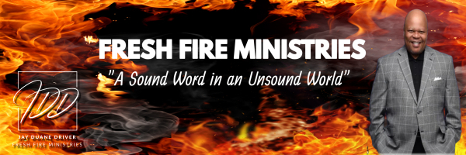

Word Wednesday Bible Study Guide

March 5, 2025

The Intersections of Life Serie: “Yesterday”

“Jesus Christ is the same yesterday, today, and forever.” Hebrews 13:8 (NKJV)

I. Subtext
A. Psalm 90:1-4

II. Reflect
- Lamentations 3:40

III. Remember Not
- Isaiah 43:18-19

IV. Reconcile
- Malachi 3:6-7

V. Redeem
A. Ephesians 5:15-17

Next Week: The Intersections of Life: “Today”

